MISSOURI CIT
PRESENTS

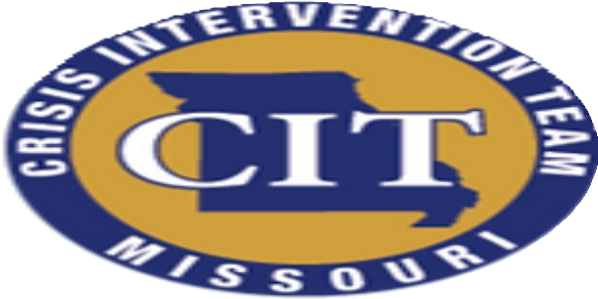
40-HOUR BASIC CIT
CONTENT INCLUDES:
*Overview of CIT
*Overview of Behavioral Health
*Suicide Prevention
*First Responder Wellness

*Substance Use/Co-occurring
*Medications
*De-escalation
*Lived Experience
*Community Resources
**AND MORE...
Law Enforcement and EMS CEU offered 40-hours in credit
**Hours varies based on chosen electives
| Interpersonal (including de-escalation and implicit bias)
| Legal
| Skill Development
| Technical Studies

