MISSOURI CIT
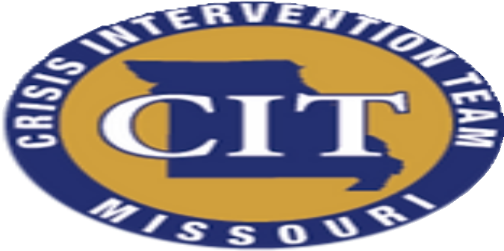
PRESENTS

JAIL CIT
CONTENT INCLUDES:
*Overview of CIT
*Overview of Behavioral Health
*Suicide Prevention

*First Responder Wellness
*Substance Use/Co-occurring
*De-escalation
*Understanding Policy and Liability of Mental Health in Corrections
*The First 48
**AND MORE...

Law Enforcement and EMS CEU's offered:
11 hours | Interpersonal (including de-escalation) 1 hour | Legal
4 hours | Skill Development
4 hours | Technical Studies

