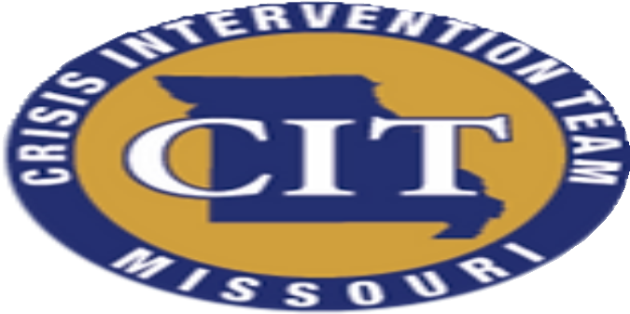
MISSOURI CIT 8-HOUR CONCEPTS COURSE
CONTENT INCLUDES:

*Overview of CIT
*Overview of Behavioral Health
*Suicide Prevention
*First Responder Wellness
*De-escalation
Law Enforcement and EMS CEU's offered:

3.5 hours | Interpersonal (including de-escalation) 1 hour | Legal
1.5 hours | Skill Development
2 hours | Technical Studies

