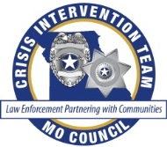

**Crisis Intervention Team Training**

**{CIT Council Name}**

**BASIC•ADVANCED•TELECOM•VETERANS•YOUTH**

**For More Information:**

*Contact Name*

*Contact Email*

*Contact Phone #*

{Local CIT Council Logo Here}

What is CIT?

Crisis Intervention Team (CIT) is an innovative first-responder model of law enforcement-based crisis intervention with community, healthcare and advocacy partnerships.

CIT training is a 40 hour POST approved training course focusing on training law enforcement in the basis assessment skills for effectively handling incidents involving individuals in a behavioral health crisis. CIT training improves the safety of law enforcement, individuals, family members and citizens within the community.

CIT reduces both stigma and the need for further involvement with the criminal justice system. CIT provides a forum for effective problem solving regarding the interaction between the criminal justice and mental health care system. It can create the context for sustainable change.

Date

Time  
Location

Address

Registration Link (if applicable)

www.missouricit.org